Sharing our stories and equipment for blended worship
5 August 2020
We asked Friends if we could gather the experience of meetings preparing for and starting blended meetings for worship – where people join online and in person for a single meeting for worship. Here are some of their stories, and some of their equipment lists, in the hope they may help others. Each situation will be different, depending on the building, the meeting, the aims and the budget. Here they are roughly in order of cost, though it depends what you already have or is loaned/donated.
You may also find it helpful to read ‘Thoughts on blended worship’ which has advice and observations gathered from discussions with Quaker meetings about setting up for blended worship.
We hope to add more stories as we receive them, probably ending this process around the end of August 2020. Do take a look at this explanation and send your contributions to supportmeetings@quaker.org.uk.

Bradford on Avon local meeting

About our meeting
We are in a small town in Wiltshire, with Friends also attending from surrounding villages and from Bath. There are two meetings for worship every week: Sundays at 10.30-11.30 (average pre-lockdown attendance around 30 adults and 5 children) and Wednesdays at 20.00-20.30 (average pre-lockdown attendance 2-3).
Online worship
We started Zoom meetings for worship on Sundays 10.30-11.30 at the end of March. Attendance varied from about 20-30 adults, with the children making occasional appearances. One of the regular Zoom attenders joins us from Cambridge. An additional Zoom Meeting on Wednesdays 20.00-20.30 was started on 22 July, coinciding with the beginning of blended worship.
Blended meetings for worship
The first blended Meeting was held on Wednesday evening 22 July, 20.00-20.30. We had 2 Friends attending in the Meeting House and a couple joining over Zoom. We expect attendance on Sundays to be averaging 6-8 in the Meeting House and 15-25 over Zoom.
Our Meeting House is fairly small, with the main meeting room seating about 40-45 maximum pre-lockdown - now down to 8 with 2m distancing. The adjacent library has space for another 4 people with 2m distancing.
Having lost all our room hire income for several months, and with a Resident Warden still on part-furlough, our criteria for blended worship kit was for it to be as cheap and as simple as possible, in line with the words on a placard in the Warden's flat: "Keep life simple".
Equipment
- Laptop: 13" Macbook from 2010, bought as refurbished second-hand kit in 2015 for £250 to replace the previous work laptop for our Warden
- Microphone: Zoom H2n digital sound recorder, privately owned by the Warden who bought it for £170 back in 2011/12.
The laptop is placed on a folding table in one of the corners of the main meeting room, with the sound recorder (on a table tripod) being plugged into it via USB, using the audio interface function - which essentially turns it into a good quality USB microphone that picks up sound from around the room.
First impressions
This entirely cost-free set-up (as the kit was already there anyway) works remarkably well. With the internal laptop speakers turned on maximum, the sound from Zoom participants is adequately transmitted to the meeting room, and the sound recorder successfully transmits the sound in the other direction (from meeting room to Zoom participants), even with the Friends worshipping in person speaking from a great distance and at differing angles to the microphone.
On the downside, the webcam only covers 5 of the 7 chairs set out in the meeting room, and the small laptop screen makes it very hard to see who's there on Zoom (although Friends with good enough eyesight may just about manage to see who's speaking, when using Zoom's speaker view).
Suggestions for improvement
The visibility of Friends on Zoom could be improved by hooking up a decent-sized monitor or TV to the laptop.

High Wycombe local meeting
About our meeting
High Wycombe meeting is part of the Chiltern Area. We regularly had 12-20 at our Meetings, but the numbers have increased for online worship – probably averaging around 25.
Online worship
We’ve used Zoom since April, basic paid subscription. There were some teething troubles, but it’s worked pretty well. Everyone that wants to use it has managed to do so. We have reduced meeting time down to 45 minutes, then have a time to catch up with each other. Sessions are led by an Elder, but this comprises no more than starting us off and ending. Because people are polite there hasn’t been a big problem with having to manage the informal discussion, though because some have had very little social contact they have embraced the opportunity to talk. Interestingly people don’t use the electronic hand gestures.
Some had problems logging on initially, but these have been resolved. I send out a group email every Saturday. We don’t use passwords but always enable waiting room. People do keep attending in their numbers, but many say they miss personal contact.
Blended meetings for worship
As lockdown has eased some were keen to return to a physical meeting, but it was also clear from others, particularly the more vulnerable, that they would not be comfortable in returning, but wanted to continue with Zoom. We therefore decided to attempt to set up the meeting house for a blended meeting.
(Area Meeting asked us to complete a plan for a retuning to the meeting house, indicating the measures we would be putting in place re hygiene, social distancing etc. This we did and we are planning to hold our first blended meeting on 2nd August).
Equipment
Three of us exchanged ideas about how this might work and, with the help of a non -Quaker ‘expert’ we decided that we’d set up the meeting house for blended worship using, if we could, bits of kit that we could put together ourselves, i.e. without, at this stage, incurring any cost. We tested out a Logitech webcam (which has a built-in microphone) and this seemed to work well. We tried a ‘dummy run’ at the meeting house. The kit was as follow:
- Webcam Logitek 1080p – see also below for another option
- Laptops 2
- Tripod on a table
- Speakers 2
- Leads
The dummy run was partially successful, Video quality was excellent, sound quality less so, though we feel we can rectify this with reasonable quality speakers.
We discussed having 2 cameras, and possibly a separate central mic, but felt that we wanted to keep things as simple as possible at this stage. We felt that the most important thing was sound quality and we are still struggling a little with this – though we do feel that the Logitech webcam will do the job. (The latest is the C922 Pro Stream HD Webcam with 30fps at 1080p & Autofocus – less than £100 – and we may go for this if/when we need to buy.)
We were very happy with the video quality– we wanted to ensure that those Zooming in got a feel of the room; we didn’t feel it mattered that they couldn’t see everyone, in detail. (To get everyone in view might not be possible – an angle of 120 degrees is I think the maximum, and would obviously show more.) We preferred the camera not too high – maybe about four to five feet, hence small tripod, on a table (though a pile of Quaker faith & practices would work) set along the wall facing the centre of the room. Useful to capture people both sitting down and standing up.
Why 2 laptops? We wanted one in the room, sat on the table next to the camera, and one in the foyer, so that a ‘technical’ meeting leader could manage Zoom – i.e. letting people in, asking to mute etc, without this disturbing the meeting. (They would welcome ‘physically’ at the same time.)

That’s where we are so far. We do not, at this stage, want to incur any costs as we plan to update the Meeting Room with more AV equipment in the near future, and were not entirely sure of the continuing need for blended meetings.
If you can find someone in your meeting with some technical knowledge this will help enormously. Use what you’ve got as far as possible. (The only kit you may need to buy is a webcam; the Logitech CP922 will cost less than £100.)
Happy to update this as we move forward.
Tom Hilton tomrhilton@gmail.com

Horsham Meeting local meeting

Blended meeting for worship
Horsham Meeting held a test blended meeting last Sunday integrating 11 Zoom participants with 8 in person (Our limit is 14 based on current risk assessment). It was pretty successful all round, enabling a gathered meeting in both forms and we certainly plan to continue this going forward, albeit with some incremental changes with eldering (we had 2 elders on zoom & 2 in person to handle welcome and ending meeting as well as muting if needed!) and technical kit as needed.
In person: We asked all Friends to let us know in advance they were coming (just used email reply). A doorkeeper outside checked off the list for Test & Trace purposes, checked on current health & required all to hand sanitise at the door.
Zoomers: exactly as we have all been doing since March. Zoomers obviously saw 2 shots inside the meeting house which showed all seats. Depend on their screen size, the details of faces were not necessarily super clear.

Equipment
We kept it relatively simple, having had a test a few days earlier. We had two laptops in different areas of the room which between them covered the whole space. We used the integrated webcam of one laptop and added an external webcam to the other. Into one laptop we linked our hearing loop system (XL 1560M Induction loop), just connecting the "line out" port from the hearing loop box by cable to the mic port on the laptop. We also had a speaker linked into that laptop. The other laptop was linked to a table standing computer monitor which showed the zoom participants.
We discovered by trial and error that when connecting the laptop running the monitor to zoom, we needed to join this "without audio" otherwise there was a lot of interference. We have three microphones in the corners of our medium sized square meeting room. The sound was apparently just a little boomy over zoom but worked ok if ministry from the meeting room was delivered slightly slower than usual. Otherwise it worked ok. Zoom ministry was super clear with speaker turned up.
We did consider using a standing microphone instead of the hearing loop but that would have meant Friends walking over to it to speak which had its own issues.
We also had planned to use our fairly new projector to show zoomers onto the plain wall but discovered a number of disadvantages to this:
- The meeting room needed to be fairly dark (blinds down) for the image to be seen - more like a cinema than M4W!.
- The projector fan was fairly distracting for silent worship.
- The picture was not as crisp as the monitor.
So the standing monitor was definitely best option for us. We placed it on one side of large oval so could be seen by all in the room but the focus of worship was still centre table and flowers, not the screen!.
Going forward
We will experiment with improvements to the hearing loop sound - doors were open some of meeting which may need adjusting. We may consult the hearing loop specialists for any technical advice. It works ok for now.
Trying out different ways of welcoming on Zoom & in person so all know who is in meeting, especially in person. Trying Elders giving a verbal welcome this week, especially to those in person, which may help zoom Friends.
In some cases Zoomers couldn’t clearly see the face of the Friend ministering and had to recognise the voice. Speakers may need to be aware to face a camera while speaking, especially for those needing to lip read.
The computer monitor was borrowed so we are on now on hunt for a second-hand one (or TV with suitable HDMI connection) that can live permanently at the meeting house and be available to hirers. 28 inch screen was minimum size for our meeting room.
Last thought
We were very clear as a meeting in thinking about blended worship that we wanted to ensure any return to worship in person was not going to be at the expense of Zoomers. We had kept up a good community while fully on Zoom with Friends from other meetings joining us. A number of Friends will not be able to return to meeting in person for quite a while so it was vital to find a set up that works well enough for everyone and as far as possible creates an integrated meeting.
I hope this is useful to some of you and enough detail. Very happy to speak to Friends individually if anyone wishes. Good luck to those trying out blended worship soon.
Helen Whittington
horshamquakermeeting@phonecoop.coop

Blue Idol local meeting

About our meeting
The Blue Idol is an old, Grade II listed building. It is part residential and has a one room meeting room. Usually we have 30 chairs in the meeting room. There is a small gallery and an Elders bench, neither of which are usually utilised on a Sunday. Our Sunday meeting for worship gathers about 20 to 25 Friends each week.
Online worship
At the beginning of lockdown we began by having the Resident Friends present in the meeting house and members of the meeting sat in their own homes sharing meeting for worship without the use of technology. After the first week we had our notices and coffee by Zoom after meeting for worship, this gave Friends a chance to try out the technology. The following week we had our first Zoom-based meeting for worship, again with our Resident Friends in the meeting house with their laptop. The Resident Friends also set up a phone camera looking out of the front door into our garden, so Friends could have even more visual connection to the meeting house. Many Friends have been joining meeting for worship using Zoom and a few have chosen not to, either way we have all felt connected and nourished by our meeting for worship.
Some other aspects
We have also had opportunities to stay connected with our notices and coffee after meeting for worship, which some Friends choose to join even if they had meeting for worship without Zoom, our weekly Zoom coffee morning and a WhatsApp group.

Blended meeting for worship
At our meeting for worship for business in July we decided we would commence a blended meeting for worship the following Sunday. In preparation for this decision an online survey (using Google Forms) was sent for Friends to complete, if they wished, asking about their experience of online meeting for worship, staying connected to the meeting during lockdown and what they hoped for next. This included asking Friends when they hoped to come to the meeting house and what would make this possible for them. A risk assessment was carried out and safety measures taken (see our website for the details). We were able to fit seven pairs of chairs at a 2 metre distance within a large circle around the perimeter of the meeting house. Four chairs are on the gallery as ‘overflow’ if needed. A marquee was put in our garden so that Friends would have weather protection if they wished to sit outside during and after meeting for worship.

Our experience so far
We have now had three blended meetings for worship. It is a learning curve for us all! We are using an online document for Friends to express their intention to come in person, so that we know who to expect and to ensure we keep within our limited capacity. Each week some Friends have chosen to sit in the garden, some using the WiFi to join Zoom and others not.
Inside the meeting house the Resident Friends have set up a laptop for Zoom, which is displayed on a larger screen using a HDMI cable, a webcam is placed where it gives a view of most of the meeting house and a speakerphone is placed on the central table.
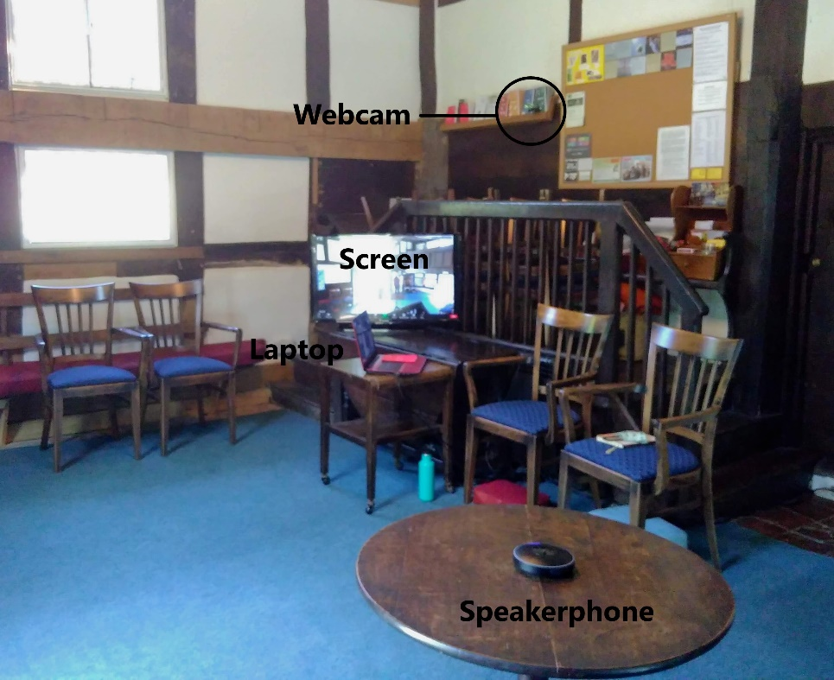
This picture is annotated to show the four pieces of equipment:

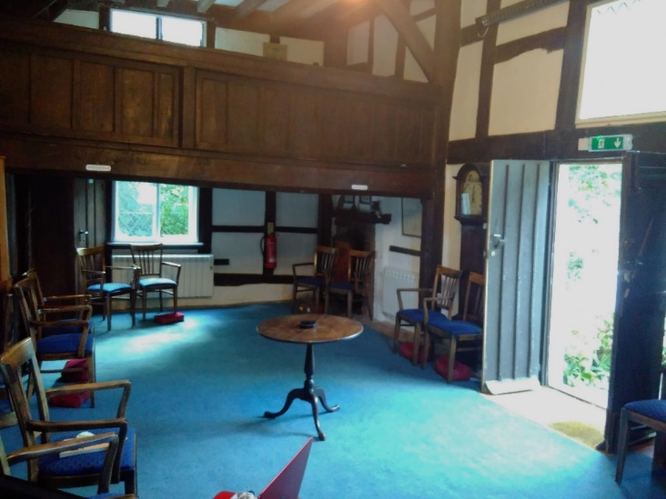
It is sad to not have flowers on the central table, we are experimenting with where they sit best instead. Some Friends find the wires and technology off-putting and unhelpful for their experience of worship. Otherwise, we have found it positive and possible!
The Friend eldering and facilitating the Zoom and technology in the meeting house has found it helpful for their own experience of meeting for worship to place the laptop to one side with the lid half closed, once everything is set up and for the duration of worship. The audio in the meeting house is left on and the microphone unmuted, for ministry to be heard in and picked up from the meeting house. An elder also joins Zoom from home. After meeting for worship we have time for notices and news, then those on Zoom continue to chat and those in the meeting house head into the garden to catch up. Some Friends bring their own coffee and tea in flasks.

Equipment
- A laptop Owned by the Resident Friends.
- WiFi Already in the residential flat, we added a ‘Devolo Magic’ WiFi extender to improve the connection in the meeting house and bring some connection to the garden.
- A freestanding flat screen Donated by a member of the meeting. This sits on a table.
- Cable A HDMI cable to connect the laptop to the screen
- Wide Angle Webcam - Bought online. £31. We added a USB extension (£3) so the webcam could be placed further from the laptop to get the best view of the room.
- Conference Speakerphone by eMeet - Bought online. £136. Connects to the laptop by Bluetooth. Picks up voices from up to 3 metres within the meeting house, as long as they are clearly spoken. Very easy to use!
In Conclusion
We have found that whilst this still feels an unusual and new way of sharing worship with Friends right now, we are willing to make the compromises and learn new ways of doing things - we are living experimentally! We would encourage other meetings to have a small group of Friends to take forward the planning - there is quite a bit of work between the risk assessment, changing the meeting house set-up, adding Covid-19 safety measures and figuring out the technology. It has been a joy to see Friends in person again, but we plan to continue our blended meeting for worship and our midweek Zoom coffee mornings for the foreseeable future as they have brought Friends together in an accessible and joyful way for many, including those who previously were not able to come to the meeting house at all or often.
28th July 2020 www.blueidol.org

Watford local meeting

About our meeting
We typically had about 35 people at meeting for worship before the pandemic, including children and young people. We have a 1950s meeting house, with a square meeting room, a library, and a modern extension with dividers we can use to make a second large room.
Online worship
We took to Zoom swiftly, and have had larger numbers attending than in the meeting house – up to about sixty, though we have come down from that peak. We had practice sessions for Zoom, and online coffee mornings, which helped people learn and adjust when not being in worship. We run a children’s meeting and a monthly teenage group, which both work well online in breakout rooms. It helped a lot that we ran practice sessions for those who help with the children’s and teenage groups, and to induct people to share out the technical hosting of the Zoom meetings.

Blended meeting for worship
We had a planning group of people from various roles, to look forwards. We surveyed Friends, and found about 24 out of 40 responding said they would like to attend meeting for worship in person. We knew there were many Friends who would wish to stay on Zoom for many months. So we considered holding blended worship at business meeting, and agreed to start this when we were ready. We had several trial runs and practices while we adjusted the equipment. With only 16 seats now available in the main meeting room, plus another 7 if people from the same households sit in pairs, we faced the prospect of needing a booking system. That felt uncomfortable. So instead, we decided to have a second room for worship, giving another 12 seats, connected by Zoom, so everyone could be part of the same meeting for worship. Friends wishing to remain outdoors to reduce risk, or not wanting the technology, are able to use a patio or the garden during meeting for worship. During August we are continuing to hold our children’s meetings online, as it is going well, and we will then review.
We held our first blended worship on 3 August, also opening the meeting house for the first time. 11 people came in person, 3 of whom sat in the garden, and we had about 30 online. If it had rained, and 6 more people had come, we would have needed to use the second room. It was a great pleasure to have several Friends who had not been joining worship online become visibly and physically part of our worship together again. They really appreciated it. On the other hand, several people who have been meeting online are now not keen on having the TV screen in the meeting room. There will be many opinions. We will be reviewing and discerning once we have some more experience.
As we expected, we will make some small adjustments next week. For example, we found our mic picked up more background sounds outside the meeting room than when experimenting, because the doors were open for ventilation. During notices and Joys & Concerns, our co-clerk couldn’t see the TV screen well, so stepped forwards to see who wanted to speak, and then had his back to the central mic and couldn’t be heard. So we learn! We will also have to reach some interesting decisions about our second room once the children’s meeting is ready to return to it, and more parents come in person. We may find that as the children go out of the main room after 15 minutes, a group of adults come in from the second room – fortunately we have several doors to help with the flow!

Our Equipment
Microphone: Our Meeting Room already had a single studio-quality microphone hanging in the centre of the room, feeding our hearing loop system. It is a Rode condenser cardioid microphone requiring phantom power, and surprisingly cost just £125. By using a simple XLR splitter we were able to take a feed from this microphone into a single channel USB pre-amp and into the laptop running Zoom. The other feed from the splitter goes as before to the pre-amp for the hearing loop.
Webcam: A simple wide-angle webcam provides a good high angle view of the meeting room. Some people can sit out of view of the webcam if they prefer.
The wifi signal was insufficient to provide a robust connection to the internet. So an ethernet cable was fitted from the router to the meeting room where it ends in a wifi repeater.
Screen: A 42” TV was lent by a Friend to provide the sound and “gallery view” of those at home. We intend to install a larger 55” TV in the future, partly for the use of hirers. Some Friends in meeting cannot see the TV easily, though some may prefer that. The TV’s speakers can be heard clearly. An alternative suggestion is to use a powered speaker and only have sound coming into the Meeting Room. We found that using our old digital projector was not strong enough to be seen well in a bright room with curtains open.
Laptop: We borrowed laptops, including one with a graphics card capable of showing up to 49 people on one Zoom screen.
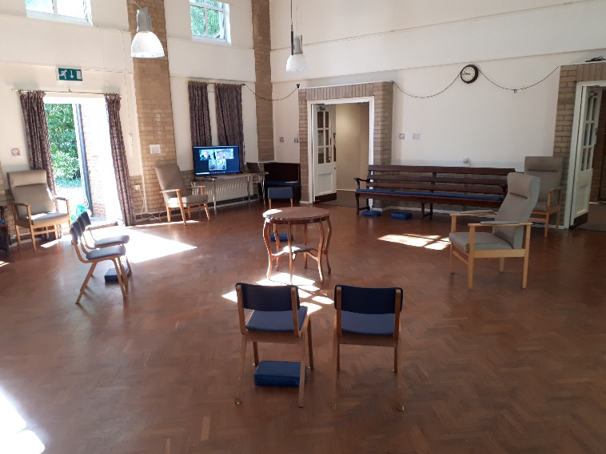
A second room was set up in case we had more people attending than could fit in the main meeting room. This also had borrowed equipment: a laptop, TV, USB wide angle camera and a USB microphone. It was close enough to the router to ensure a good internet connection.
TV Mic Webcam Wire from splitter Second room:
Webcam Mic Speaker TV Laptop

We will need to buy a TV, as we need to return a borrowed one soon. We also need to buy a PC as we cannot always be borrowing a laptop, or one with the high specification graphics card, and it will be good to have this with a TV in the main meeting room – though it maybe simplest for hirers to plug in their own laptops. Those decisions have yet to be made. We have made our first step, and will adjust and learn as we go along.
www.watfordquakers.org.uk

Oxford local meeting
Our meeting house
We have 9 letting rooms of varied size suiting everyone from one to one therapies up to conferences. We have been installing TV screens and all the equipment to enable video conferencing in our meeting house and another couple of rooms.
Our preparations
It’s been an uphill struggle/steep learning curve - bit like the whole lockdown process. However today I finally placed the order for equipment and labour and hope to have it installed for when Oxford starts its first in-person meeting 1st week of August – thus enabling "blended" worship in at least one room.
Premises and Finance Group approved spending on upgrading some of our 9 letting rooms in June because we recognise that with vastly reduced room capacities the only way we could be viable in the future is to encourage groups back by being able to use good zoom or similar facilities. This is also in line with trying to minimise travel into central Oxford for many. So, for example, Citizens Advice training could have 4 people in attendance and perhaps 10 more on screen from around the country. We also of course have many Friends who need to continue to shield for the duration but who need to feel connected to the place and the people they love.
We contacted the company in Oxford with whom we have a contract to sort our computer problems (and we have had a few – mostly due to dodgy, randomly assembled equipment over the years put together by well-meaning but then unavailable volunteers). We have gradually got on a more professional footing now – funded by increasing our letting income – and have fewer problems. Our company worked on a quote which our next Premises and Finance Group meeting reviewed, deciding to run it by a member who works in the computer department of the University to get a second, informed opinion. Moral – there's always someone you haven't thought of who knows more than you and wants to help. You will know if you trust them and if so pause and take advice. We then went back to our company with some recommended cheaper alternatives to kit to get a similar result for less cash. The company came back with a revised quote and we are now going ahead.
Our Equipment
Main Meeting House Room capacity 100, now post-COVID: 24
Equipment (in English): big telly on mobile stand with dedicated mini PC to control. Webcam for boundary view. Using our loop system and radio mikes plus possibly small add on speakers. We have Anker sound core mini speakers – quite adequate – and also a larger sound system for film shows so we will mackle something out of that.
TV | Toshiba 55" 4K Ultra HD HDR Display- 3840 x 2160 Resolution - 4x HDMI Connectivity - VESA Mountable- Weight: 15.5Kg- 2-4 Working Day Delivery | £425.00
Mini PC | Refurbished HP ProDesk 400 G2 Mini PC. - Intel i3-6100T Processor - 240GB SSD - 8GB DDR4-2133MHz RAM - DisplayPort / VGA Connectivity - Windows 10 Pro - 1-Year Warranty | £230.00
Wireless Keyboard and Mouse | Logitech | £20.00
TV Trolley Stand | RFIVER TV Trolley Stand- Supports 27" - 55" TV's with VESA Compatible Mounts - Height Adjustable and Rotatable Mount - Mount Supports up to 50Kg Weight - Shelves Support up to 15Kg Weight- Integrated Cable Management System- 5-Year Manufacturer Warranty- Height: 123.5cm - 133.5cm, Width: 60cm-2-4 Working Day Delivery | £68.00
Webcams with mic | Logitech C930e Webcam- 1080p Full HD Quality - Wide Angle Lens (90°? Field of View)- Built-in Mic | £119.00
Labour | Labour for Onsite Installation of TV and Mini PC. This would cover: Building the TV stand, Mounting the TV, Connecting Mini PC to the Network and finishing off any extra required prep. Estimated 2 hours labour @ £88 p/hour | £176.00
 | Labour for Prepping Mini PC, Updating Windows to the latest version, Updating Drivers, Configuring any required setup | £68.00
Total |  | £1,106  + VAT £221 = £1327.20

Long Room/Upstairs Capacity was 18, now post-COVID is 7.
This is in our main building and the reason to have similar kit on a stand is so it can be moved to another room. I would have preferred a wall mounted setup but we can always adapt and change as we go along. Similar English definition to above but smaller TV as smaller room.
TV | Philips 43" 4K Ultra HD Display - Wall-mountable - 3x HDMI Connectivity - Weight: 8Kg | £300.00
Mini PC | Refurbished HP ProDesk 400 G2 Mini PC. Intel i3-6100T Processor - 240GB SSD - 8GB DDR4-2133MHz RAM - DisplayPort / VGA Connectivity - Windows 10 Pro - 1-Year Warranty | £230.00
Wireless Keyboard and Mouse | Logitech | £20.00
TV Trolley Stand | RFIVER 27" - 55" TV Trolley- Supports 27" - 55" TV's with VESA Compatible Mounts - Height Adjustable and Rotatable Mount - Mount Supports up to 50Kg Weight - Shelves Support up to 15Kg Weight- Integrated Cable Management System- 5-Year Manufacturer Warranty- Height: 123.5cm - 133.5cm, Width: 60cm- 2-4 Working Day Delivery | £68.00
Webcams with mic | Logitech C930e Webcam- 1080p Full HD Quality - Wide Angle Lens (90° Field of View)- Built-in Mic | £119.00
Labour | Labour for Onsite Installation of TV and Mini PC  This would cover: - Building the TV stand - Mounting the TV - Connecting Mini PC to the Network and finishing off any extra required prep | £176
 | Labour for Prepping Mini PC- Updating Windows to the latest version - Updating Drivers  - Configuring any required setup | £68
Total |  | £981  + VAT £196  = £1,177.

So, for in the region of £2500 we will have two flexible set ups – be Zoomtastic.
Of course we are increasing the Zoom licenses to allow more concurrent meetings to happen (when we have anyone who is permitted to return!). We will allow groups to come in with their own equipment for small-scale laptop Zooms etc. We could have bought a job lot of bits and screwed it together but we may have screwed it up! – as so many of us have done in the past. We also know if something goes awry, our company will be with us within an hour and that means a lot when you have a conference breathing down your neck (as we one day hope to see again!).
We are trying to get Elders/Clerks/Pastoral Care/Trustees involved together in whether we can supply the most isolated and vulnerable Friends with smart phone/tablets and simply training – it’s taking time. We are probably only talking about 3 or 4 people here but the need is there and now. We really do need to find ways of being more supportive and creative about all this "stuff".
Deb Arrowsmith
Manager

Central Bristol local meeting
About our meeting room
Our main meeting room is 7m x 10m and 5m high – 350cubic metres of volume – so it needs speakers and microphone systems thought about by an AV expert so that the results do not disappoint. One of the long walls comprises three large windows on the sunny side of the building. Curtains are fitted.
Our Equipment
The wall mounted screen is fitted to the adjoining wall i.e. at right angles to the window wall. We used a 135 inch (diagonal) screen which sounds huge but fits the purpose well. The projector is central mounted in the ceiling. It is very important that the brightness (lumens) of the projector is designed for not only the distance to the screen, but also produces an image visible in daylight. We fitted a 6000 lumens LED type – very bright.
Speakers are fitted high up in each corner, about 1m from the ceiling, and are quite unobtrusive. We already had a 19” rack for the hearing loop, and our hardware was fitted into this neatly. It is an 18`U rack ( where one U is 1¾ inches) so it as about 1m high overall with a transparent lockable door.. This is the best way to enclose all this kit otherwise there would be wires everywhere, and perhaps difficulties with cooling. In order to connect a laptop or microphones to the system, a connector panel was made and fitted to the side of the 19” rack. This contains an HDMI socket, two microphone sockets with volume controls, a USB port, and a master volume (output) control.
We already have WiFi and a laptop. A laptop may be sat on top of the 19” rack, or set on a table as for a conference. So we have a 5m long HDMI lead.
We chose to have a wireless microphone to simplify handing between those wishing to use it. An aside on our hearing loop. There is a hearing loop with a central ceiling mounted microphone. This was originally badly designed and doesn’t work too well!. The design doesn’t work because the loop is installed at ceiling/wall level 5m up, whereas it was designed for a standard ceiling height. The strength of the magnetic field projected by this loop of course drops off as the inverse square of the distance so that for seated hearing aid users, the signal strength is about ¼ of what is required. But that’s another story.
We have an ethernet port fitted in the wall near the 19” rack, so that said laptop can connect directly to the internet. Our wifi system is not yet proven to work reliably enough in that corner of the meeting house, so the ethernet socket may be pressed into use.
All this was installed in February just before lockdown, we have no real experience of its usability, apart from testing it. It is capable of use for blended meetings but not yet trialled. We did not attempt integration with the hearing loop, as yet.
Our designers provided the equipment and fitted it in two days. Post COVID, you are welcome to come and take a look. We can recommend our supplier, who works throughout the UK, contact details on request.
- Panasonic PTVMZ60 Projector £2,500
( List price is £3,500, so we got a bargain )
- Wall mounted Electric Projector screen 135” £600
- Ceiling Projector mount £98
- Cloud MPA120MK2 Amplifier mixer £478
- Revamp 2120T Amplifier £450
- Speakers x4 Apart Mask 6CT Wht £120 £480
- Local Input Control plates custom made for inputs £252
- Wireless microphone £41
- Misc and wires £355
- Others

  - Extra long mains Projector leads
  - Extra long mains Projector screen cabling
  - Speaker cabling
  - Category 6 cabling (HDMI)
  - HDMI over Cat 6 Extender
  - HDMI & Surface mounted input plate
  - Audio Interconnects
  - Projector audio cable
  - Rack mounted cooling fan for existing rack
  - Rack shelf
  - Rack blanking plates
  - 6 Way Anti surge block
  - Cage nuts
  - Surface trunking

- Installation works: £695
_________________
- Grand Total £5,949

