# Using the Yearly Meeting Planner: an introduction

## Contents

* About the Yearly Meeting Planner
* Signing in for the first time
* Signing in again (i.e. the second time and onwards)
* Choosing events
* See more information about an event
* See a list of events you have booked
* Search for an event
* Changing your mind
* Reminders of events you have booked
* How to enter an event/session when it is about to start
* Important things to remember

## About the Yearly Meeting Planner

The Yearly Meeting Planner serves a number of purposes:

* It provides a full programme of events
* It allows you to book for events
* It enables you to enter events you have booked for
* It allows you to contact the help desk, pastoral care, elders, arrangements committees, the epistle drafting group and other Quaker Groups who have provided their information.

We have tried to keep the instructions straightforward. Below are some of the things people commonly ask us about. If you still find things confusing or something doesn’t appear to be working, do contact the Yearly Meeting Helpdesk (details at the end of this document) and we can arrange alternative support!

The notes below are based on doing things on a computer. It will be similar on an iPad or tablet, device but not quite the same. So if you need help that, do let us know.

## Signing in for the first time

You should have received a welcome email when your registration was processed. If it did not arrive, it may have ended up in your spam folder, or been blocked by your email provider. If you registered for Yearly Meeting Gathering last year, you may not have received another email this year.

If you have the welcome email, click on the link in that email to set up your account. This will give you the opportunity to set a password.

If you did not receive the welcome email, or cannot find it, go to

<https://ym2022.sched.com/>

From there you can use the ‘forgot password’ option to set or reset your password.

You will then be signed in and given your profile page where you can put a bit of information about yourself. This is not compulsory.

Then select "Schedule" from the menu (see image)

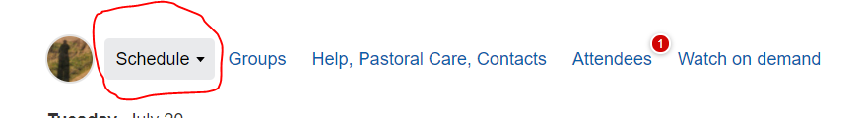

On this page you can decide whether to allow other participants to see the information about you. This will include details of the events you book. So if you do not wish people to see any of that, then best keep your profile private (it will be private by default).

You will also be able to choose whether to receive messages from us. We recommend you allow us to send messages via Sched as this will enable us to keep you informed about changes to the programme, send you email reminders of the events you have booked, etc.

## Signing in again (i.e. the second time and onwards)

Go to <https://ym2022.sched.com>

Enter your email address and password

You will then be signed in as above, and will see the full list of events.

## Choosing events

Scroll down the page to see the events (in chronological order).

To book for an event or Yearly Meeting session, click on the little circle next to the event title and it will change to a “tick” (see image)

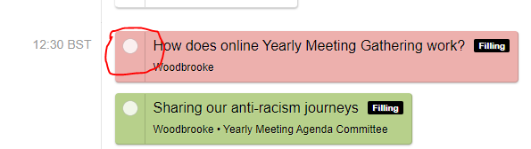

Becomes

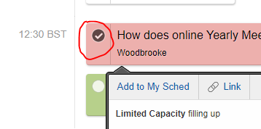

If an event is full you will get a message to say you have been added to the waiting list. Once a place becomes available you will then automatically be assigned that place. It’s worth checking your schedule from time to time to see what has opened up, should you yourself be on waiting lists.

## See more information about an event

On the main screen, described above, you only see the title of the event and who is running it. For more information, ‘click’ on the title of the event and you will be taken to a page dedicated to that event, including  a description of the event.

From here you can also book for the event as described above.

To get back to the main events list, you can do one of the following:

1. Click on ‘Schedule’ in the menu above the events list (as described earlier)
2. Click on “Back to schedule”, which is usually on the right hand side of the page, at the top of the events list
3. Use the ‘back’ button in your web browser (how this works varies depending on what you are using)

## cid:part6.199D6C8A.53F89236@alisonleonard.co.ukSee a list of the events you have booked

To the left of the menu at the top of the events list (next to ‘Schedule’) you will see a circular icon. It may contain your initials or an image of a person.

Move your mouse over this and a menu will appear below (see image).

Click on “My Sched”

You will be shown a list of your booked events.

## Search for an event

Use the search box on the right to search for what you want (see image below). E.g. if you type in "experiment", and press "Search" it will give you a list of all the Experiment with Light sessions.

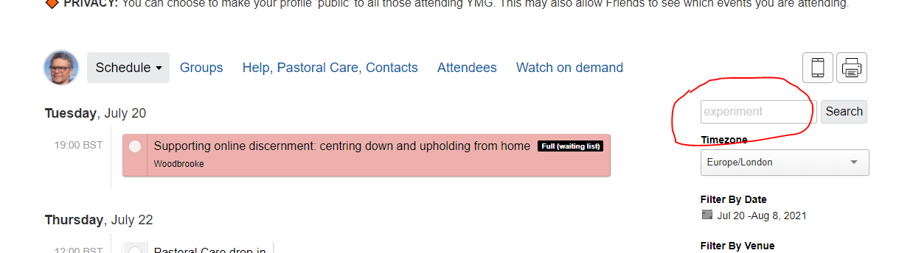

## Changing your mind

If you booked for event but can no longer attend, please go into your schedule and “de-select” it by clicking on the little circle with a tick in it.

This will free up space for another Friend to attend. Most events have a limit on numbers, either because of the nature of the event, or because of technical limits on Zoom.

## Reminders of events you have booked

Every day during YM you will receive an email with the list of events you have booked. If you have not booked any that day, it will show you the first few events for that day. You will be able to click through from that email to get into the YM Planner as described above.

## How to enter an event/session when it is about to start

We do not send out Zoom links. To connect to a session, visit the YM Planner or your daily email and click/tap on the session title. This will take you to the detailed page about the event on the YM Planner (see ‘To see more information about an event’, above).

10 minutes before the event a highlighted button will appear with the text, “Enter meeting”. Click on this button to enter the meeting.

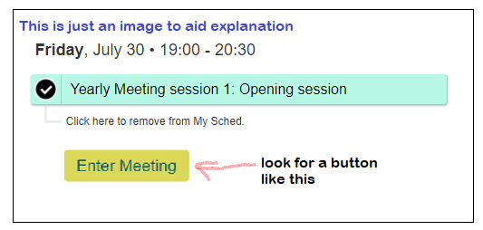

### Try it out

We have set up some test sessions so you can practice getting into meetings. Look out for “[**Practice: getting used to the YMG Planner and joining meetings**](https://ymg2021.sched.com/editor/schedule?id=1c38c8523cc1be64bc9dffcbfad12059#edit)” on the YMG Planner. You can book for these events, or just turn up. They will be unstaffed. If you get to the meeting waiting room, you have been successful and can close the Zoom connection.

## Important things to remember

### Install Zoom

Most events take place in Zoom. You will need to have the Zoom app installed on your device. Zoom gets updated regularly. While most things will work, even with an older version, we recommend that you update the app to avoid issues. Zoom provide a short video describing how to do this <https://www.youtube.com/watch?v=E7zERcVLUBM>

### Cancel your booking if you can no longer attend

Many events are oversubscribed. If you no longer wish to attend an event, please cancel as early as possible so others can use the space.

### Waiting lists

If someone cancels a place, it will automatically be offered to the next person on the waiting list. The email will come from ‘Sched’ with the subject line “**You made it off the waitlist**”. You won’t need to do anything else, unless you no longer need the place, in which case please cancel it.

## If you need help

Send an email to the YM Helpdesk: [ym@quaker.org.uk](mailto:ym@quaker.org.uk)   
or you can phone 020 7663 1040 (you may have to leave a message)

Yearly Meeting Helpdesk: [ym@quaker.org.uk](mailto:ym@quaker.org.uk)

YM website: [www.quaker.org.uk/ym](http://www.quaker.org.uk/ym) (all YM documents are here)

YM Planner: [ym2022.sched.com](https://ym2022.sched.com) (you must be registered for Yearly Meeting)

Help pages: [www.quaker.org.uk/ym/help](http://www.quaker.org.uk/ym/help)