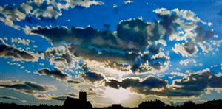
ART EXHIBITION
An exhibition of work by local artist
Claire Dowson
The Friends Meeting House
Pakefield Street, Lowestoft, NR33 0JP

Private View 7pm Friday 7th October
Open Saturday 8th October 10am-4pm
Sunday 9th October 12am-4pm
10th – 13th 11am-4pm

claire@clairelouisedowson.co.uk
www.norfolkandwaveneyquakers.org.uk

